**OLABISI ONABANJO UNIVERSITY**

College of Engineering & Environmental Studies

Faculty of Engineering

Ibogun Campus.

**MECHANICAL ENGINEERING DEPARTMENT**





**FLUID MECHANICS**

**LABORATORY MANUAL**

**200 LEVEL**

**NAMES……………………………………………………………………………………………………**

**MATRIC. NO. :……………………………………… LEVEL: ………………………………………**

**DEPT.: ………………………………………………...GROUP NO:...…………………………………**

**COURSE:………………………………………………. CODE: …..…………………………………..**

**DATE:…………………………… SESSION: ……………………SIGNATURE…………………….**

** OLABISI ONABANJO UNIVERSITY**

**COLLEGE OF ENGINEERIG & ENVIRONMENTAL STUDIES**

**DEPARTMENT OF MECHANICAL ENGINEERING**

**IBOGUN CAMPUS**

**FLUID MECHANICS LABORATORY**

**EXPERIMENT 1**

**Title: Determination of Flow Measurement**

**Objectives**: (i) To measure the fluid flow (ii) To determine flow rate of the fluid

(iii) to determine the fluid density

**Equipment/Materials**: Volumetric bench, centrifugal pump, flexible hose, water, stop watch.

**Introduction**

The Hydraulic Bench provides the necessary facilities to support a comprehensive range of hydraulic models, each of which is designed to demonstrate a particular aspect of hydraulic theory.

The particular laws involved are those of mass, energy and momentum conservation and, in each application, these laws may be simplified in an attempt to describe the fluid, quantity of the fluid and the fluid behaviour.

Fluid mechanics developed as an analytical discipline from the application of the classical laws of static, dynamics and thermodynamics, in situations in which fluids can be treated as continuous media.



Figure 1.1: Volumetric Bench

A centrifugal pump draws water from sump tank and drives it through a vertical pipe. A control valve assembled in an external panel is used to regulate the flow in the pipe, which ends in a mouthpiece placed in the channel and has a quick connection connector. The male connector allows a quick substitution of the different accessories, which are supplied with a flexible tube ending in a female connector. Special purpose terminations may be connected to the pump supply by unscrewing the connector. No hand tools are required for any of these operations.

The moulded bench top incorporates an open channel, with side channels, to place the accessory on test. The channel incorporates a pair of wall slots and a weir, for use with accessory, in addition to the inlet connector.

A dump valve in the base of the volumetric tank is operated by a remote actuator.

Lifting the actuator, the dump valve opens allowing the inlet water to return to the sump for recycling. When lifted, a twist of 90º at the actuator will retain the dump valve in the open position.

An overflow made on a side of the volumetric tank, returns water to the sump in case an excessive height is reached. When working with an accessory, the water discharged is collected in a volumetric measuring tank. This tank is stepped to accommodate low or high flow rates and incorporates a stilling baffle, to reduce turbulence. At sight, a level tube, with a scale, is connected to the base of the volumetric tank and gives an instantaneous indication of water level.

A drain valve is incorporated in the wall of the sump to facilitate draining. A measuring cylinder is provided for the measurement of very small flow rates. The electrical supply to the motor-pump is made with an on-off switch placed on the bench. It also includes a **5A** fuse holder.

**Flow Measurements**

The bench top incorporates a volumetric measuring tank, which is stepped to accommodate for low or high flow rates. A stilling baffle is placed adjacent to the open channel, to reduce turbulence.A sight gauge consisting of a transparent tube and a scale, is connected to a connector in the base of the tank and gives an instantaneous indication of the water level. The scale is divided into two zones corresponding to the volume above and below the step in the tank. Finally, there is a remote hand-operating dump valve, in the base of the volumetric tank.

**Procedure**

1. Switch on the centrifugal pump.
2. Open the dump valve to empty the measuring tank.
3. When the measuring tank is empty, connect the pump and close the dump valve.
4. Write down the reading of the level tube (manometer)
5. Switch the chronometer (Stop watch) on and stop when you reach the required quantity.
6. Record your readings in tabular form,
7. Calculate the flow as it is illustrated in the following equation:

.

**Table 1.1: Table of values**

|  |  |  |  |  |  |  |
| --- | --- | --- | --- | --- | --- | --- |
| S/N | Final volume (L2)  (Litres) | Initial volume (L1)  (Litres) | Change in volume (∆L)  (Litres) | Time taken(t)  (sec) | Volumetric flow rate (Q)  (Litres/sec.) | Mass flow rate (ṁ)  (kg/sec) |
| 1 |  |  |  |  |  |  |
| 2 |  |  |  |  |  |  |
| 3 |  |  |  |  |  |  |
| 4 |  |  |  |  |  |  |
| 5 |  |  |  |  |  |  |
| 6 |  |  |  |  |  |  |
| 7 |  |  |  |  |  |  |

**Exercises**

1. Plot the graph of change in volume (∆V) against the time (sec)
2. Determine the slope of the graph in (a), what parameter does it reflect?
3. What is the equation of the line?
4. Estimate the average mass flow rate and volumetric flow rate
5. Of what importance is the flow rate of a fluid?
6. What are the possible precautions necessary to be observed?

***NOTE on flow measuring:***

***Warning: When finish the flow measures with the chronometer, the valve actuator must be pulled down to open the valve and empty the tank to avoid that the sump tank is empty and to prevent damaged of the centrifugal pump. When another time taking is going to be done, the actuator has to be pulled up to fill the volumetric tank and once finished the measurement, the actuator will be pulled down again.***

***PRACTICAL REPORT***

***EXPERIMENT: 1***

***Title:……………………………………………………………………………………………………………………………………………………***

Aims/Objectives:

………………………………………………………………………………………………….......................................................…..................................................................................................................................................................……………………………………………………………………………………………………........................................................................................................................................................................................................................……………………………

***Equipment/Apparatus/Materials:***

***………………………………………………………………………………………………………………………………………………………………………………………………………………………………………………………………………………………………………………………...***

***Theory:***

………………………………………………………………………………………………….......................................................…..................................................................................................................................................................……………………………………………………………………………………………………........................................................................................................................................................................................................................……………………………

………………………………………………………………………………………………….......................................................…..................................................................................................................................................................……………………………………………………………………………………………………........................................................................................................................................................................................................................……………………………

………………………………………………………………………………………………….......................................................…..................................................................................................................................................................……………………………………………………………………………………………………........................................................................................................................................................................................................................……………………………

………………………………………………………………………………………………….......................................................…..................................................................................................................................................................……………………………………………………………………………………………………........................................................................................................................................................................................................................……………………………

………………………………………………………………………………………………….......................................................…..................................................................................................................................................................……………………………………………………………………………………………………........................................................................................................................................................................................................................……………………………

………………………………………………………………………………………………….......................................................…..................................................................................................................................................................……………………………………………………………………………………………………........................................................................................................................................................................................................................……………………………

***……………………………………………………………………………………………………………………………………………………………………………………………………………………………………………………………………………………………………………................................................................................................................................................................……………***

***Diagram(s):***

a. Plot the graph of change in volume (∆V) against the time (sec)

Attach graph sheets

b. Determine the slope of the graph in (a), what parameter does it reflect?

………………………………………………………………………………………………….......................................................…..................................................................................................................................................................…………….………………………………………………………………………………………........................................................................................................................................................................................................................……………………………

c. What is the equation of the line?

........................................................................................................................................................................................................................................................................................................................................................................................................................................................................................................................

........................................................................................................................................................................

d. Estimate the average mass flow rate and volumetric flow rate

................................................................................................................................................................................................................................................................................................................................................

........................................................................................................................................................................................................................................................................................................................................................................................................................................................................................................................

.................................................................................................................................................................................................................................................................................................................................................................................................................................................................................................

e. Of what importance is the flow rate of a fluid?

………………………………………………………………………………………........................................................................................................................................................................................................................……………………………

………………………………………………………………………………………………….......................................................…..................................................................................................................................................................……………………………………………………………………………………………………........................................................................................................................................................................................................................……………………………

………………………………………………………………………………………………….......................................................…..................................................................................................................................................................……………

f. What are the possible precautions necessary to be observed?

………………………………………………………………………………………………….......................................................…..................................................................................................................................................................……………………………………………………………………………………………………........................................................................................................................................................................................................................……………………………

………………………………………………………………………………………………….......................................................…..................................................................................................................................................................……………………………………………………………………………………………………..............................................................................

Reference(s):

……………………………………………………………………………………………………………………………………………………………………………………………………………………………………………………………………………………………………………………………………………………………………………………………………………………………………….......................................................…..................................................................................................................................................................……………………………………………………………………………………………………........................................................................................................................................................................................................................……………………………

**EXPERIMENT 2**

**TITLE**: Determination of volume and density of an object by the Archimedes’ Principle

**INTRODUCTION**

Experimentally, when a body is partially or totally submerged in a fluid it appears that, the body weighs differently in the air than when it is out of the fluid. Similarly, when it is in the fluid it displaces an amount of the fluid equal to the volume of the body submerged. The basis of the principle of buoyancy was discovered by Archimedes principle.

**OBJECTIVES**

The objectives of the experiment are:

(i) to determine the volume of metal cube.

(ii) to determine the density of metal cubes.

**APPARATUS/MATERIIALS:**

Metal cube, Vernier calliper, Micrometer screw gauge, Spring balance, thread

**THEORY**

A body weighing in air experiences a reduction in weight when completely immerse in a fluid. The volume of the body corresponds to the values of length and diameters of the solid body. The density of a substance is equal to the ratio of its mass to volume.

Hence, Density = mass/volume

Volume = mass/density

*Spring balance*

Figure 2.1: Suspended solid body on spring

**PROCEDURE:**

a.Take the vernier calliper and measure the length of the metal cube given to you in range

1. Measure the diameter of the metal cube given to you in range and record you readings
2. Suspend the metal cube by means of a thin thread from the spring balance and record its weight (W1) in air.
3. Repeat (i) for all the metal cube in range (10g, 20g, 30g, 40g, 50g, 60g, …..) and record their readings on the spring balance.
4. Record your readings in tabular form.

**EXERCISES:**

Values for metal cubes:

Mass (kg) =

Length (m) =

Diameter (m) =

Calculate the volume of the metal cube =

Determine the density of the metal cube =

Table 2.1: Table of Results

|  |  |  |  |  |  |
| --- | --- | --- | --- | --- | --- |
| S/N | Mass | Length | Diameter | Volume | Density |
|  |  |  |  |  |  |

**RESULTS AND CALCULATIONS**

1. Plot a graph of *Mass M* against *Volume V* for each of the metal cubes provided.

2. Determine the slope of each of these graph, hence deduce the values of their various densities.

3. Compare the calculated volume with experimental volume from your graph.

4. Compare the calculated density with experimental density from your graph.

5. Explain the Principles of buoyancy.

***PRACTICAL REPORT***

***EXPERIMENT: 2***

***Title:……………………………………………………………………………………………………………………………………………………***

Aims/Objectives:

………………………………………………………………………………………………….......................................................…..................................................................................................................................................................……………………………………………………………………………………………………........................................................................................................................................................................................................................……………………………

***Equipment/Apparatus/Materials:***

***………………………………………………………………………………………………………………………………………………………………………………………………………………………………………………………………………………………………………………………...***

***Theory:***

………………………………………………………………………………………………….......................................................…..................................................................................................................................................................……………………………………………………………………………………………………........................................................................................................................................................................................................................……………………………

………………………………………………………………………………………………….......................................................…..................................................................................................................................................................……………………………………………………………………………………………………........................................................................................................................................................................................................................……………………………

………………………………………………………………………………………………….......................................................…..................................................................................................................................................................……………………………………………………………………………………………………........................................................................................................................................................................................................................……………………………

………………………………………………………………………………………………….......................................................…..................................................................................................................................................................……………………………………………………………………………………………………........................................................................................................................................................................................................................……………………………

………………………………………………………………………………………………….......................................................…..................................................................................................................................................................……………………………………………………………………………………………………........................................................................................................................................................................................................................……………………………

………………………………………………………………………………………………….......................................................…..................................................................................................................................................................……………………………………………………………………………………………………........................................................................................................................................................................................................................……………………………

***…………………………………………………………………………………………………………………………………………………………………………………………………………………………………………………………………………………………………………………………***

***Diagram(s):***

**EXERCISES:**

Values for metal cubes:

Mass (kg) =

Length (m) =

Diameter (m) =

Calculate the volume of the metal cube =

Determine the density of the metal cube =

1. Plot a graph of againstfor each of the metal cubes provided.

Attach graph sheets

2. Determine the slope of each of the graph

........................................................................................................................................................................................................................................................................................................................................................................................................................................................................................................................ ………………………………………………………………………………………………….......................................................…..................................................................................................................................................................……………………………………………………………………………………………………........................................................................................................................................................................................................................……………………………

………………………………………………………………………………………………….......................................................….........

........................................................................................................................................................................

Hence, deduce the values of their various densities.

................................................................................................................................................................................................................................................................................................................................................

........................................................................................................................................................................................................................................................................................................................................................................................................................................................................................................................

3. Compare the calculated volume with experimental volume from your graph.

................................................................................................................................................................................................................................................................................................................................................ ………………………………………………………………………………………………….......................................................…..................................................................................................................................................................……………………………………………………………………………………………………........................................................................................................................................................................................................................……………………………

4. Compare the calculated density with experimental density from your graph.

......................................................................................................................................................................................................................................................................................................................... ………………………………………………………………………………………………….......................................................…..................................................................................................................................................................……………………………………………………………………………………………………........................................................................................................................................................................................................................……………………………

………………………………………………………………………………………………….......................................................…..................................................................................................................................................................……………

5. Explain the Principle of buoyancy.

.........................................................................................................................................................……………………………………………………………………………………………………........................................................................................................................................................................................................................……………………………

………………………………………………………………………………………………….......................................................…..................................................................................................................................................................……………………………………………………………………………………………………........................................................................................................................................................................................................................……………………………

………………………………………………………………………………………………….......................................................…..................................................................................................................................................................……………………………………………………………………………………………………........................................................................................................................................................................................................................……………………………

………………………………………………………………………………………………….......................................................…..................................................................................................................................................................……………………………………………………………………………………………………........................................................................................................................................................................................................................……………………………

………………………………………………………………………………………………….......................................................…..................................................................................................................................................................……………………………………………………………………………………………………........................................................................................................................................................................................................................……………………………

***……………………………………………………………………………………………………………………………………………………………***

Precaution(s):

………………………………………………………………………………………………….......................................................…..................................................................................................................................................................……………………………………………………………………………………………………........................................................................................................................................................................................................................……………………………

………………………………………………………………………………………………….......................................................…..................................................................................................................................................................……………………………………………………………………………………………………........................................................................................................................................................................................................................……………………………

***……………………………………………………………………………………………………………………………………………………………***

Reference(s):

………………………………………………………………………………………………….......................................................…..................................................................................................................................................................……………………………………………………………………………………………………........................................................................................................................................................................................................................……………………………

………………………………………………………………………………………………….......................................................…..................................................................................................................................................................……………………………………………………………………………………………………........................................................................................................................................................................................................................……………………………

***……………………………………………………………………………………………………………………………………………………………***

**EXPERIMENT 3**

**TITLE: Determination of fluid density by the principle of buoyancy**

**INTRODUCTION**

When a body is partially or totally submerged in a fluid, it displaces an amount of the fluid equal to the volume of the body submerged. Similarly, the body appears to the weight differently when out of the fluid and when in the fluid. The basis of the principle of buoyancy was discovered by Archimedes principle.

**OBJECTIVES:**

(a)To determine the relation between the change in weight (Mass) of the submerged body and the volume of fluid displaced. (b) To determine the density of various fluids by the relation of their up thrust and volume of fluid displaced.

**APPARATUS/MATERIIALS**: Spring balance, Metal cube, String (rope), fluids

**THEORY:** A body weighing in air experiences a reduction if weight W when completely immerse in a fluid. The volume of the body (totally submerged) corresponds to the volume of fluid displaced while the apparent weight loss W describes the up thrust force acting in the body. Fig. 1.1 illustrates the above mentioned.

Measuring Cylinder

Metal Cube

Thread

Liquid

Spring Balance

Figure 3.1: Buoyancy Experimental set up

**PROCEDURE:**

1. Suspend the metal cube by means of a thin thread from the spring balance and record its weight W1 in air.
2. Next, note the reading of the Liquid Level L1 in the measuring cylinder A1. Note that the new reading of the Liquid Level and hence the change in volume V.
3. Also, take the new reading of the spring balance W2.
4. Record your result weight in air, weight in Liquid, Mass in air, Mass in Liquid, Loss in Mass, initial and final liquid level and the change in Liquid in tabular form.
5. Repeat the procedure for Liquid L2, L3, and L4, using each time metal cubes of mass 20, 30, 40, 50, 60, 70, 80g, and 50g, 100g, 150g, 200g & 250g.

**RESULTS AND CALCULATIONS**

**EXERCISES:**

1. Plot a graph of against for water, Kerosene and Diesel liquids provided.

2. Determine the slope of each of these graph, hence deduce the values of their various densities.

3. Suppose you have plotted a graph of the change in weight against. What parameter would    the slope of the graph reflect?

4. Explain the significance of buoyancy in the parachute and the hot air balloon.

5. Describe briefly how the hydrometer measures the relative density of a liquid.

6. A cube made of Oak and of side 15cm floats in water with 10.5cm of its depth below the surface and    its side vertical. What is the density of the Oak?

7. A body of density 9.0g/cm3 appears to have a mass of 27.0g in a liquid of density 1.2g/cm3.

What is the volume of the solid?

8. State Archimedes’ Principles.

***PRACTICAL REPORT***

***EXPERIMENT: 3***

***Title:……………………………………………………………………………………………………………………………………………………***

***Aims/Objectives:***

………………………………………………………………………………………………….......................................................…..................................................................................................................................................................……………………………………………………………………………………………………........................................................................................................................................................................................................................……………………………

***Equipment/Apparatus/Materials:***

***………………………………………………………………………………………………………………………………………………………………………………………………………………………………………………………………………………………………………………………...***

***Theory:***

………………………………………………………………………………………………….......................................................…..................................................................................................................................................................……………………………………………………………………………………………………........................................................................................................................................................................................................................……………………………

………………………………………………………………………………………………….......................................................…..................................................................................................................................................................……………………………………………………………………………………………………........................................................................................................................................................................................................................……………………………

………………………………………………………………………………………………….......................................................…..................................................................................................................................................................……………………………………………………………………………………………………........................................................................................................................................................................................................................……………………………

………………………………………………………………………………………………….......................................................…..................................................................................................................................................................……………………………………………………………………………………………………........................................................................................................................................................................................................................……………………………

………………………………………………………………………………………………….......................................................…..................................................................................................................................................................……………………………………………………………………………………………………........................................................................................................................................................................................................................……………………………

………………………………………………………………………………………………….......................................................…..................................................................................................................................................................……………………………………………………………………………………………………........................................................................................................................................................................................................................……………………………

***…………………………………………………………………………………………………………………………………………………………………………………………………………………………………………………………………………………………………………………………***

***Diagram(s):***

2. The slope of each graph,

........................................................................................................................................................................................................................................................................................................................................................................................................................................................................................................................ ………………………………………………………………………………………………….......................................................…..................................................................................................................................................................……………………………………………………………………………………………………........................................................................................................................................................................................................................……………………………

………………………………………………………………………………………………….......................................................….........

........................................................................................................................................................................ Deduction of the fluids density values.

................................................................................................................................................................................................................................................................................................................................................

........................................................................................................................................................................................................................................................................................................................................................................................................................................................................................................................

3. Suppose you have plotted a graph of the change in weight against . What parameter would    the slope of the graph reflect?

................................................................................................................................................................................................................................................................................................................................................ ………………………………………………………………………………………………….......................................................…..................................................................................................................................................................……………………………………………………………………………………………………........................................................................................................................................................................................................................……………………………

4. The significance of buoyancy in the parachute and the hot air balloon.

......................................................................................................................................................................................................................................................................................................................... ………………………………………………………………………………………………….......................................................…..................................................................................................................................................................……………………………………………………………………………………………………........................................................................................................................................................................................................................……………………………

………………………………………………………………………………………………….......................................................…..................................................................................................................................................................……………

.........................................................................................................................................................……………………………………………………………………………………………………........................................................................................................................................................................................................................……………………………

………………………………………………………………………………………………….......................................................…..................................................................................................................................................................……………………………………………………………………………………………………........................................................................................................................................................................................................................……………………………

………………………………………………………………………………………………….......................................................…..................................................................................................................................................................……………

5. Describe briefly how the hydrometer measures the relative density of a liquid.

......................................................................................................................................................................................................................................................................................................................... ………………………………………………………………………………………………….......................................................…..................................................................................................................................................................……………………………………………………………………………………………………........................................................................................................................................................................................................................……………………………

………………………………………………………………………………………………….......................................................…..................................................................................................................................................................……………

.........................................................................................................................................................……………………………………………………………………………………………………........................................................................................................................................................................................................................……………………………

………………………………………………………………………………………………….......................................................…..................................................................................................................................................................……………………………………………………………………………………………………..............................................................................

6. A cube made of Oak and of side 15cm floats in water with 10.5cm of its depth below the surface and its side vertical. What is the density of the Oak?

......................................................................................................................................................................................................................................................................................................................... ………………………………………………………………………………………………….......................................................…..................................................................................................................................................................……………………………………………………………………………………………………........................................................................................................................................................................................................................……………………………

………………………………………………………………………………………………….......................................................…..................................................................................................................................................................……………

.........................................................................................................................................................……………………………………………………………………………………………………........................................................................................................................................................................................................................……………………………

………………………………………………………………………………………………….......................................................…..................................................................................................................................................................……………

7. A body of density 9.0g/cm3 appears to have a mass of 27.0g in a liquid of density 1.2g/cm3. What is the volume of the solid?

......................................................................................................................................................................................................................................................................................................................... ………………………………………………………………………………………………….......................................................…..................................................................................................................................................................……………………………………………………………………………………………………........................................................................................................................................................................................................................……………………………

………………………………………………………………………………………………….......................................................…..................................................................................................................................................................……………

.........................................................................................................................................................……………………………………………………………………………………………………........................................................................................................................................................................................................................……………………………

………………………………………………………………………………………………….......................................................…..................................................................................................................................................................……………………………………………………………………………………………………........................................................................................................................................................................................................................……………………………

………………………………………………………………………………………………….......................................................…..................................................................................................................................................................……………………………………………………………………………………………………........................................................................................................................................................................................................................……………………………

………………………………………………………………………………………………….......................................................…..................................................................................................................................................................……………………………………………………………………………………………………........................................................................................................................................................................................................................……………………………

………………………………………………………………………………………………….......................................................…..................................................................................................................................................................……………………………………………………………………………………………………........................................................................................................................................................................................................................……………………………

***……………………………………………………………………………………………………………………………………………………………***

8. State Archimedes’ Principles.

..........................................................................................................................................……………………………

………………………………………………………………………………………………….......................................................….........………………………………………………………………………………………………….......................................................…..................................................................................................................................................................……………………………………………………………………………………………………........................................................................................................................................................................................................................……………………………

***……………………………………………………………………………………………………………………………………………………………***

Precaution(s):

………………………………………………………………………………………………….......................................................…..................................................................................................................................................................……………………………………………………………………………………………………........................................................................................................................................................................................................................……………………………

………………………………………………………………………………………………….......................................................….........

Reference(s):

………………………………………………………………………………………………….......................................................…..................................................................................................................................................................……………………………………………………………………………………………………........................................................................................................................................................................................................................……………………………

………………………………………………………………………………………………….......................................................…..................................................................................................................................................................……………………………………………………………………………………………………........................................................................................................................................................................................................................……………………………

**EXPERIMENT 4**

**TITLE: CENTRE OF PRESSURE APPARATUS**

**Aim/Objective**: To determine the moment of the fluid pressure acting on the plane surface.

**Equipment/ Apparatus**: Perspex tank, fluid (water), weight (mass), weight hanger, spirit level, coloured ink,

**Introduction**

Definition of Centre of Pressure: Centre of pressure may be defined as the point in a plane at which the total fluid thrust can be said to be acting normal to that plane.

The Centre of Pressure Apparatus permits the moment due to the fluid thrust on a wholly or partially submerged plane surface to be measured directly and compared with theoretical analysis. Provision is made for varying the inclination of the plane surface subjected to the fluid pressure so that the general case may be studied.

**Description of Apparatus**

Water is contained in a quadrant of a semi-circular Perspex tank assembly which is allowed to swing on a smooth bar. The cylindrical sides of the quadrant have their axes coincident with the centre of rotation of the tank assembly, and therefore the total fluid pressure acting on these surfaces exerts no moment about that centre. The only moment present is that due to the fluid pressure acting on the plane surface. This moment is measured experimentally by applying weights to a weight hanger mounted on the opposite side to the quadrant tank.

A second tank, situated on the same side of the assembly as the weight hanger, provides a trimming facility and enables different angles of balance to be achieved.

The angular position of the plane and height of water above it are measured on an angular scale engraved on the tank and linear scale panel.

Included with the apparatus are base levelling feet and a spirit level.

With the quadrant tank of the hopper fabrication held to the right-hand side, fit the hopper fabrication onto the centre support of the main frame assembly.

Level the base plate by screwing the adjustable feet and observing the spirit level.

A coloured dye is supplied with the apparatus, which can be added to the water to help observation during experimentation. It should only be necessary to add small amount of dye (one or two cupful) to produce suitable colouring.

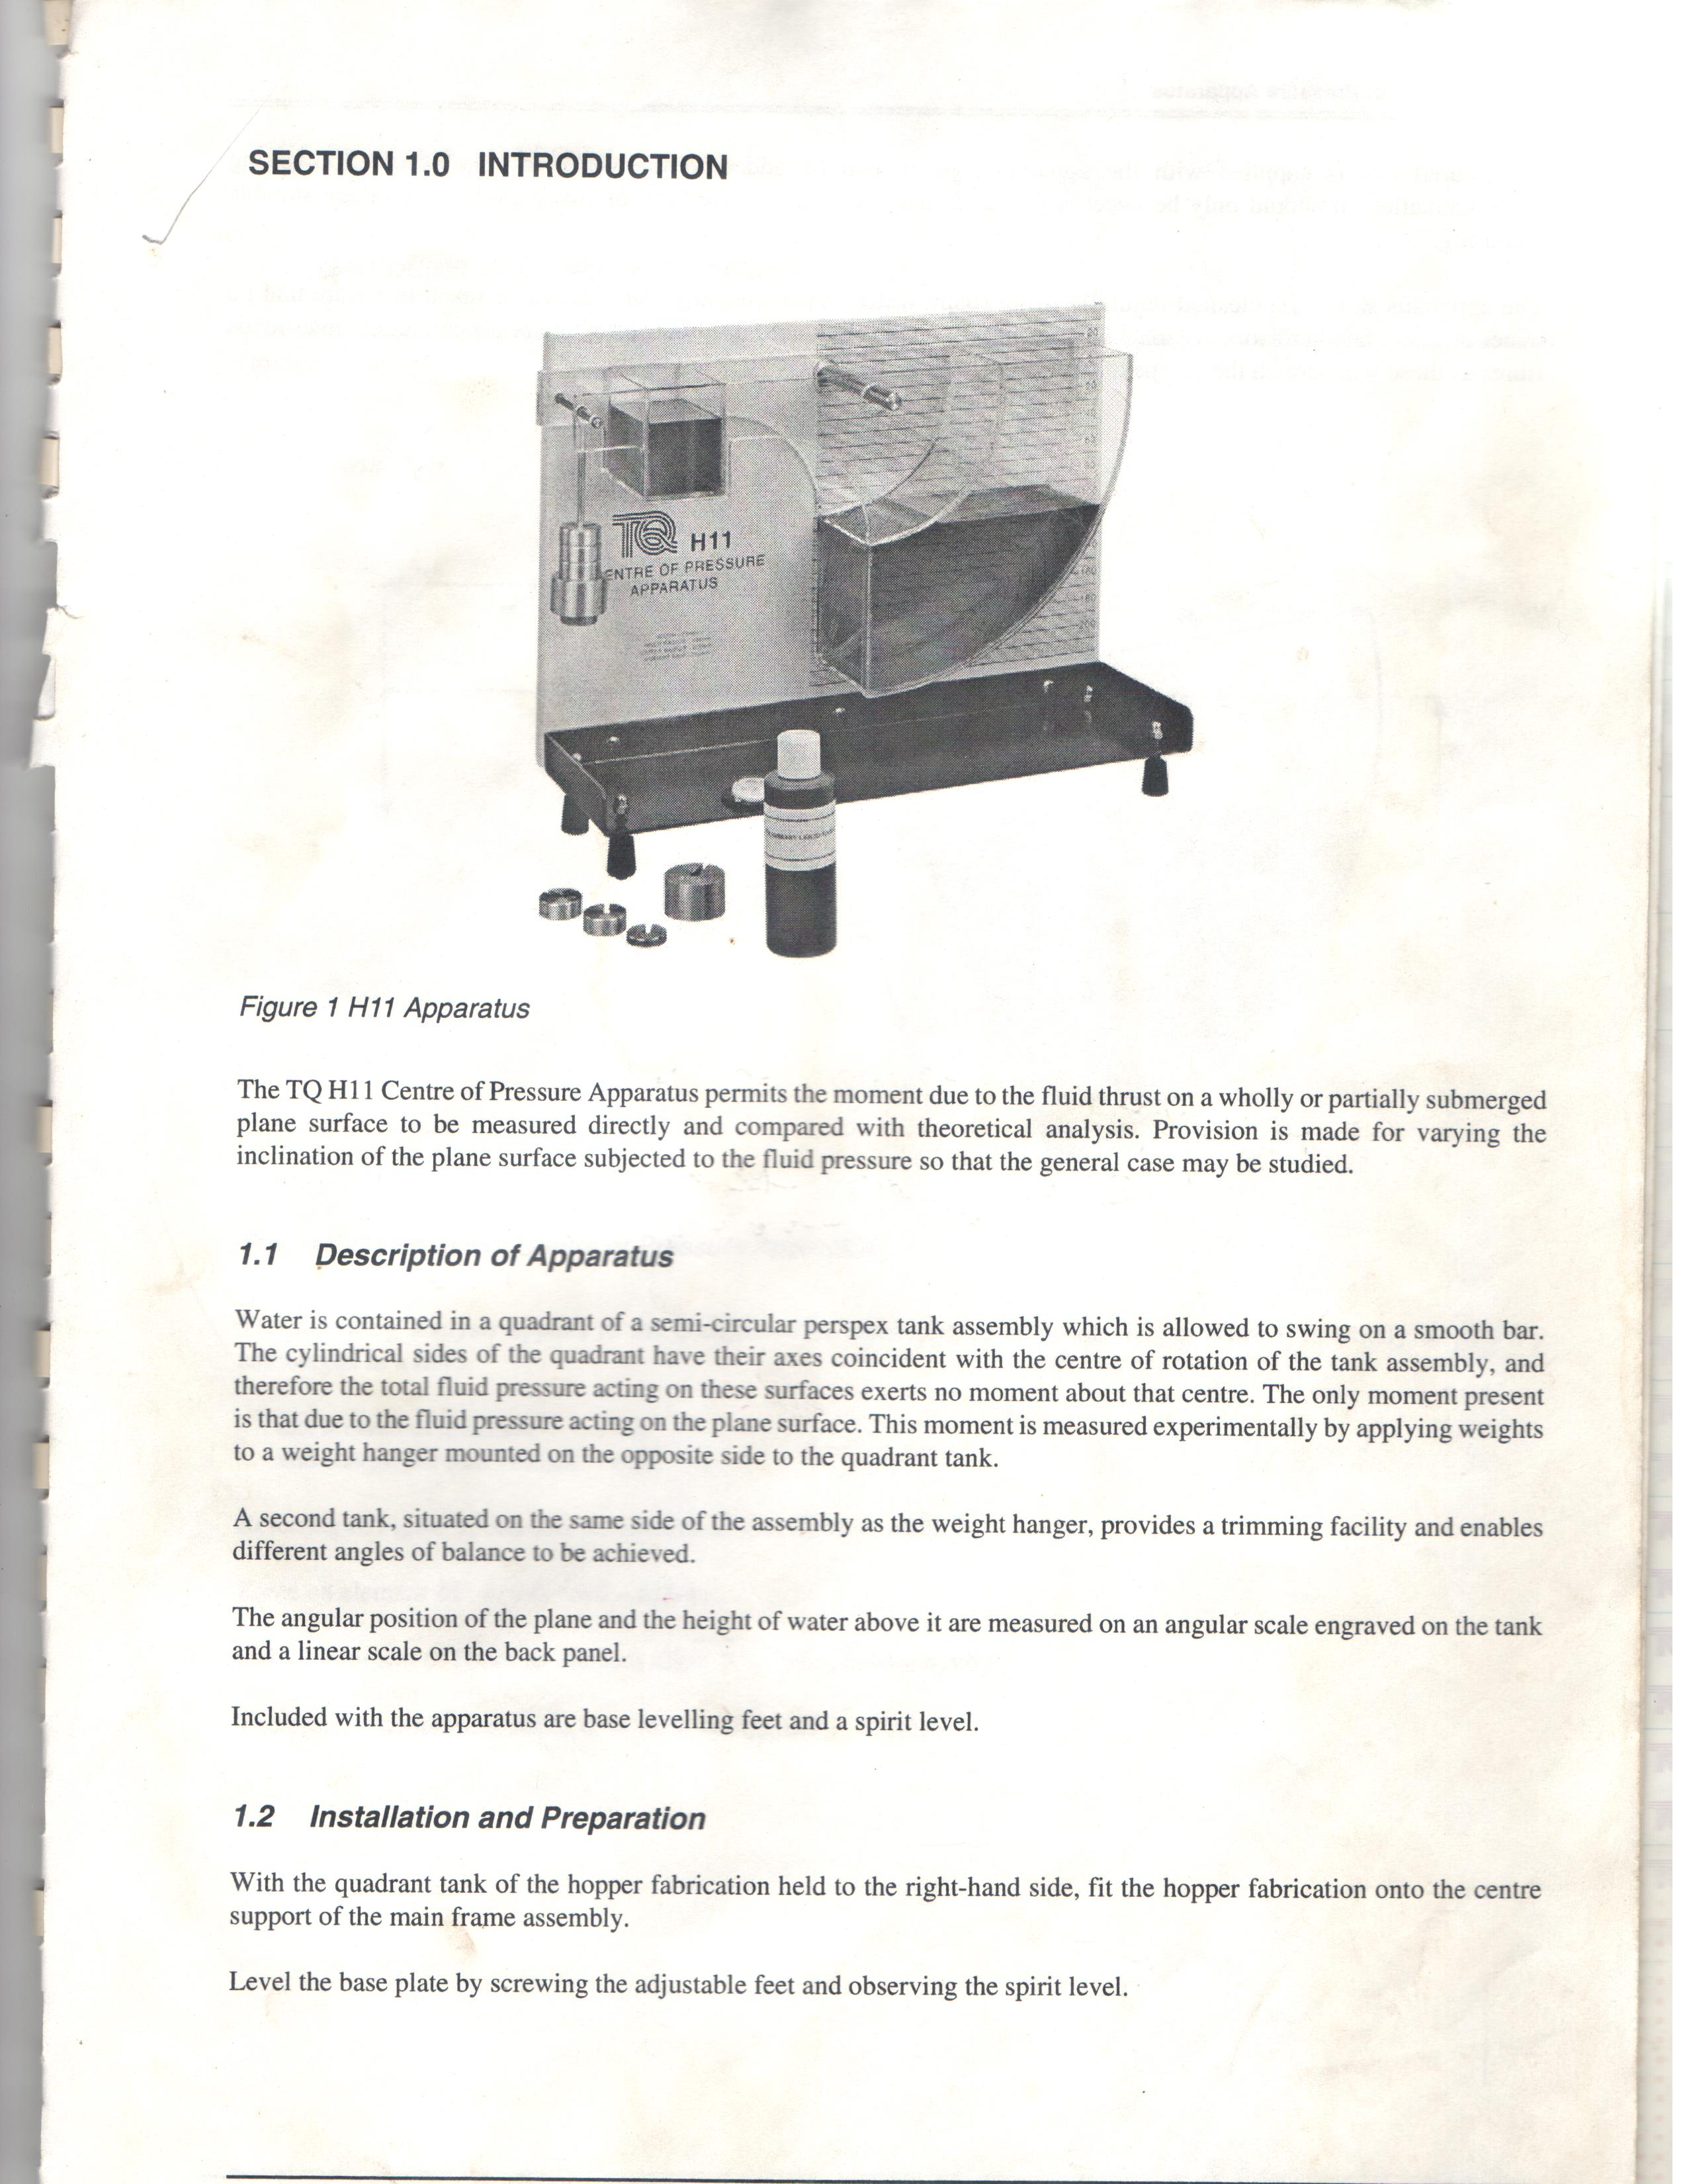

Figure 4.1: Centre of Pressure Apparatus

**Theory:**

Centre of pressure may be defined as the point in a plane at which the total fluid thrust can be said to be acting normal to that plane.

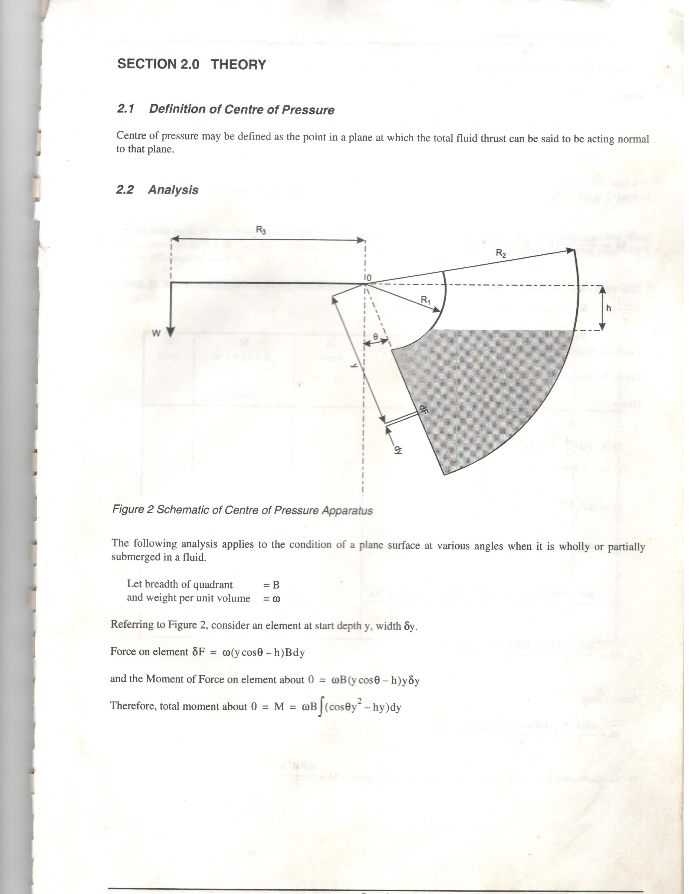

Figure 4.2: Schematic of Centre of Pressure Apparatus

Analysis:

The following analysis applies to the condition of a plane surface at various angles when it is wholly or partially submerged in a fluid.

Let breadth of quadrant = B

And weight per unit volume = w

Referring to Figure 4.2 consider an element at start depth y, width Δy.

Force on element Δf = w(y cos θ – h) B Δy

And the moment of force on element about 0 = w B(y cos θ – h) y Δy

Therefore, total moment about 0 = M= wB (cosθy2 – hy) Δy

**Experimental Procedure:**

(i) Set up the equipment as previously described above, and affix the weight hanger to the hanger     support located on top of the hopper.

(ii) The apparatus will now require trimming in order to bring the submerged plane to the vertical (i.e 0o position). This is achieved by gently pouring water into the trim tank until the desired position is achieved. The horizontal line on the tank assembly should be read against the zero line on the back scale.

(iii) Add a 20g weight (w) to the weight hanger. Pour water, with dye added if necessary, into the quadrant tank until a 0o­­ balance is restored.

(iv) Note the weight and the height reading of the water (h).

(v) Repeat the procedure for the full range of weights.

Readings should be tabulated in the table below and the results calculated in line with the theory given above.

Table 4.1: Table of results

|  |  |  |  |  |  |  |
| --- | --- | --- | --- | --- | --- | --- |
| W (gm) | M = (Nm) | h (mm) | h (m) | h3 (m3) | M+(ωBR22h/2)(Nm) | θ0 |
|  |  |  |  |  |  |  |
|  |  |  |  |  |  |  |

Figures 4.3 and 4.4 show the general form of the graphs expected from this experiment.

000

= 0o

h (m)

M (Nm)m)

Figure 4.3: Graph shown plane fully submerged

h3 (m3)

M+(ωBR22/2)

Figure 4.4: Graph shown plane partially submerged

The results obtained from this experiment tend to agree very well with results calculated from hydrostatic theory. Disagreement between observation and theory is likely to be due to error in measurement or the construction tolerances of the apparatus rather than to any imprecision of the theory.

The apparatus should be cleaned regularly using soap water. When cleaning, care should be taken to ensure that no traces of grit or any hard abrasive materials are present on used cloth used. Do not use any materials containing man-made fibres as these will scratch the Perspex.

EXERCISES:

1. Plot the graph of M against h.
2. Determine the slope of the graph in (a).
3. Plot the graph of M+(ωBR22h/2) (Nm) against h3 (m3).
4. Determine the slope of the graph in (b).
5. What is the moment of the fluid pressure?
6. What are the precautions to be observed in the experiment?

***PRACTICAL REPORT***

***EXPERIMENT: 4***

***Title:……………………………………………………………………………………………………………………………………………………***

***Aims/Objectives:***

………………………………………………………………………………………………….......................................................…..................................................................................................................................................................……………………………………………………………………………………………………........................................................................................................................................................................................................................……………………………

***Equipment/Apparatus/Materials:***

…………………………………………………………………………………………………………………………………………………………………………………………………………………………………………………………………………………………………...........……………………...

***Theory:***

………………………………………………………………………………………………….......................................................…..................................................................................................................................................................……………………………………………………………………………………………………........................................................................................................................................................................................................................……………………………

………………………………………………………………………………………………….......................................................…..................................................................................................................................................................……………………………………………………………………………………………………........................................................................................................................................................................................................................……………………………

………………………………………………………………………………………………….......................................................…..................................................................................................................................................................……………………………………………………………………………………………………........................................................................................................................................................................................................................……………………………

………………………………………………………………………………………………….......................................................…..................................................................................................................................................................……………………………………………………………………………………………………........................................................................................................................................................................................................................……………………………

………………………………………………………………………………………………….......................................................…..................................................................................................................................................................……………………………………………………………………………………………………........................................................................................................................................................................................................................……………………………

………………………………………………………………………………………………….......................................................…..................................................................................................................................................................……………………………………………………………………………………………………........................................................................................................................................................................................................................……………………………

***…………………………………………………………………………………………………………………………………………………………………………………………………………………………………………………………………………………………………………………………..............................................................................................................................................................................................................................................................................................................................................................................................................................................................................................................................................................................................................................................................***

***Diagram(s):***

a. Attach graph sheets ....

a. Determine the slope of the graph in (a)

........................................................................................................................................................................................................................................................................................................................................................................................................................................................................................................................ ………………………………………………………………………………………………….......................................................…..................................................................................................................................................................……………………………………………………………………………………………………........................................................................................................................................................................................................................……………………………

………………………………………………………………………………………………….......................................................….........

........................................................................................................................................................................ c. Attach a graph sheet ....

b. Determine the slope of the graph in (b)

................................................................................................................................................................................................................................................................................................................................................

........................................................................................................................................................................................................................................................................................................................................................................................................................................................................................................................

c. What is the moment of the fluid pressure?

................................................................................................................................................................................................................................................................................................................................................ ………………………………………………………………………………………………….......................................................…..................................................................................................................................................................……………………………………………………………………………………………………........................................................................................................................................................................................................................……………………………

d. What are the precautions to be observed in the experiment?

......................................................................................................................................................................................................................................................................................................................... ………………………………………………………………………………………………….......................................................…..................................................................................................................................................................……………………………………………………………………………………………………........................................................................................................................................................................................................................……………………………

………………………………………………………………………………………………….......................................................…..................................................................................................................................................................……………

Reference:

………………………………………………………………………………………………….......................................................…..................................................................................................................................................................……………………………………………………………………………………………………........................................................................................................................................................................................................................……………………………

………………………………………………………………………………………………….......................................................…..................................................................................................................................................................……………